Career Research

Home

Library Resources for Career Research
The Library subscribes to many sources of information on companies and industries. These can be very useful tools for researching a company that has invited you to interview or an industry where you are interested in working.

Graduate Career Development Resources Collection
The Graduate Career Development Resources Collection is a collaboration between UChicagoGRAD and the Library, and is made possible through the generous support of Danette (Dani) Gentile Kauffman and Diane Adams.
Location:
The collection is located in the second floor reading room of the Regenstein Library near the Current Periodicals and Newspapers. There is a sign identifying the collection. You can also browse the collection via our catalog.

UChicago Resources for Career Research

UChicago Grad Career Exploration

Resources for graduate students at the University of Chicago for career success.

Career Advancement

Resources for UChicago college students to find employment, internships, or network with alumni.

LinkedIn Learning

Take free online courses to add technology, software, business, and creative skills on your résumé.

Graduate Studies in Library Science

Resources for finding library schools and library jobs from the Library

- Researching Legal Employers
by D'Angelo Law Librarians Updated May 21, 2025

Subject Specialists
Contact:
Greg Fleming
Emily Treptow
Regenstein Library Room 360
Social:Facebook PageInstagram Page
Subjects:Business, Economics

Research an Industry

Industry Overviews
The Library has many sources that give broad overviews of specific industries. The level of detail can vary, depending on the industry.

IBISWorldThis link opens in a new window

This has the broadest scope of our resources. Our subscription covers only the U.S. and also has state specific industry reports.

& more

S&P Global NetAdvantageThis link opens in a new window

Covers 50+ industries at the macro level.

& more

More Resources
Our guide to Industry Research has more resources, including guides to researching specific industries.
- Conducting Industry Research
by Business & Economics Librarians Updated Aug 5, 2025

Research a Company

Researching a Company: the Basics
What does the company say?
Visit the company's web and social media sites and read any annual reports. Press releases are also good sources of information
What do others say?
Articles in trade journals and newspapers are excellent sources of analysis and can help you form your own picture of a company's situation

Key Secondary Resources

FactivaThis link opens in a new window

News database that has over 20,000 sources. Search for your company name and key executives to find how they've been covered in the news and trade publications.

& more

Business Source CompleteThis link opens in a new window

Includes profiles of over one million companies worldwide as well as articles from trade journals and other sources.

& more

ProQuest One BusinessThis link opens in a new window

Includes trade journals, newspapers and press releases.

& more

S&P Global NetAdvantageThis link opens in a new window

Has international coverage of private companies.

& more

More Resources
Find more resources for researching your company on our Company Information guide
- Company Information
by Business & Economics Librarians Updated Oct 1, 2025

Deep Dive: Analyst Reports
Investment analysts produce detailed reports on publicly traded companies. These often have information that is harder to dig out of articles or company reports. The downside is that accessing them is more difficult and uses a very specialized database called Refinitiv Workspace.
Our guide to using Refinitiv Workspace includes information on accessing these reports.

Research a Career

Books in the Library's Collections

Career Guides
Find career information on duties, education and training, pay, and outlook for hundreds of occupations. Use subject headings Vocational Guidance or Occupations -- United States in the Library catalog to find resources like the book listed below.

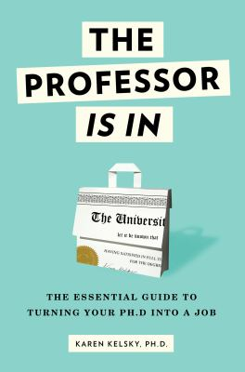The Professor Is In by Karen Kelsky

Call Number: HF5382.7.K45 2015

ISBN: 9780553419429

Publication Date: 2015-08-04

The definitive career guide for grad students, adjuncts, post-docs and anyone else eager to get tenure or turn their Ph.D. into their ideal job.

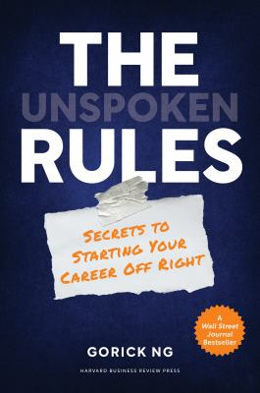The unspoken rules : secrets to starting your career off right by Gorick Ng

Call Number: Full-text online

ISBN: 9781647820459

Publication Date: 2021

This book is a guide to help early career professionals, especially those from underrepresented backgrounds, navigate the school-to-work transition and ascend to positions of leadership, based on 500+ interviews with professionals across geographies, industries, and job types.

Job Hunting
Learn how to find a job and land a job with the skills you've developed in academia. Job hunting guides provide advice in communicating your skills, succeeding in interviews, and getting hired. Browse books similar to the one below by searching Job Hunting as a subject in the library catalog.

The ultimate job hunting book : write a killer CV, discover hidden jobs, succeed at interview by David McWhir

Call Number: Full-text online

ISBN: 9781787856585

Publication Date: 2020
From crafting the perfect CV and finding the job of your dreams, to writing a great cover letter and winning at interview, The Ultimate Job Hunting Book is a dynamic collection of tools, techniques, and strategies for success. Short, punchy chapters mean you can read up quickly and start applying what you've learned immediately

Research beyond UChicago

Research After Graduation
Resources highlighted on this guide are subscription databases and won't be available to you after graduation. There are many free resources that can be helpful and there are article databases available to alumni.
These free sites can be useful starting points:
Yahoo! Finance
Yahoo! Finance offers free access to information about publicly traded companies.
Glassdoor
Glassdoor combines job listings with reviews of companies by current and former employees. The reviews can give you insight on a company, but be sure to consider them carefully.
Free registration required

Library Resources for Alumni
Some databases are available to alumni from off-campus.
- Electronic Resources for Alumni
by Ask a Librarian Updated Sep 30, 2025

Other Libraries
Most public libraries offer some company databases, such as Hoovers or ReferenceUSA. Check with your local library to identify what's available to you.

